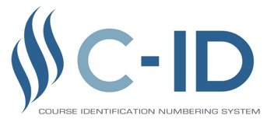
Transfer Model Curriculum 5-Year Review Summary - Sociology
Please attach a copy of the vetting results for the TMC to the document.
- Provide a breakdown of the respondents to the survey:
- # of CCC respondents: 23
- # of CSU respondents: 2
- # of UC respondents: 1
- Total responses: 26
Provide a written summary of the feedback from the survey to the question below:
- Were there any changes suggested to the List A of the TMC?
FDRG recommends: Latest list as of 2/20 accepted.
- Were there any changes suggested to the List B section of the TMC?
FDRG recommends: Includes Research Methods as choice.
- If appropriate, were there any changes suggested to the List C section of the TMC?
FDRG recommends: Eliminated from TMC
- Please provide any general recommendations from the feedback received from the vetting.
FDRG recommends: Changed Statistics as a required course in the core, with Research Methods as choice on List A.
Provide a written summary of the FDRG’s recommendations and attach a copy of the revised TMC, including the date of completion of the review.
In order to mesh our TMC with the UC system, Statistics was recommended as a core option, although many colleges still consider the Methods course essential but dropped to List A as highly recommended. Social problems was considered for removal but many felt the retention of the course in the core essential.

